Virtual Lab 3 – Waveguide
Pre-Laboratory
Understand TE and TM modes in a rectangular waveguide. Understand cutoff frequency, propagating modes and evanescent modes. Understand TEM, TE and TM modes in a coaxial line. Understand TE and TM modes in a circular waveguide.

Rectangular Waveguide

- Create an air-filled rectangular waveguide with dimensions of 22.86×10×100 mm³. The cross section dimensions of this rectangular waveguide (shown in red color) corresponds to a WR-90 waveguide (X-band)
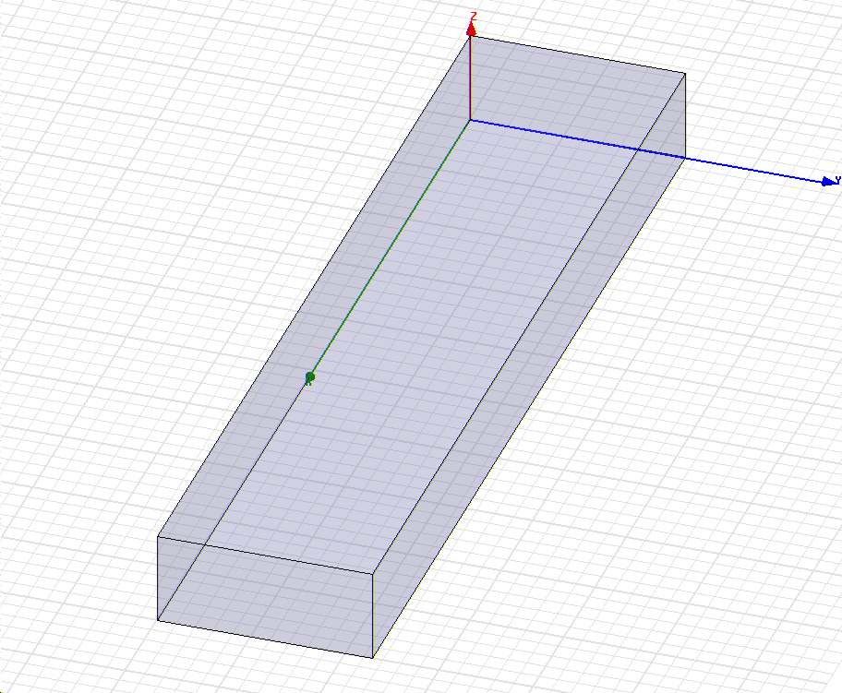
Port 1
Port 2
- Assign wave ports as shown.
- Solve at 6 GHz, 10 GHz and 15 GHz respectively and plot the E field magnitude (Mag_E) on the top surface of the waveguide at each frequency point. Plot the vector electric current (Vector J_Surf) on the top surface and one side wall at 10 GHz.
- Identify all the modes which can exist at 18 GHz. Change number of modes in “Excitation”→ “waveport” → “number of modes” to the number of modes you calculated. Solve at 18 GHz. Plot the vector E and H fields for each mode and provide the corresponding name of each mode.
- Read the impedance (at Port 1) at 8, 10, 12 GHz.

Coaxial Line:

- Draw a coaxial line: inner conductor diameter = 50 mil (Note: mil is not the same as mm); outer conductor diameter = 170 mil; the dielectric inside the coaxial line ε_{r} =2.1; length = 10 mm. Solve at a frequency slightly above the cut off frequency of the first higher-order mode, with the TEM mode being called the fundamental mode.

Circular Waveguide

- Draw a circular waveguide with a radius of 0.5 cm and a length of 20 mm. Solve at a frequency slightly above the cut off frequency of 1st higher-order mode.

Lab Reports

Rectangular Waveguide

- (10 pts) Plot the E field magnitude on the top surface of the waveguide for 6, 10, and 15 GHz. From the field plot, determine whether it is a propagating mode or evanescent mode at each frequency.
- (10 pts) Calculate the guided wavelength λ_{g} at 10 GHz using the equation in the book and compare with the guided wavelength read from the field plots.
- (10 pts) Calculate how many modes can exist at 18 GHz and identify the name of each mode.
- (10 pts) Plot the vector E and H fields of each mode and provide the name of the mode in the plot.
- (10 pts) Plot the vector electric current on the top surface and one side wall for TE₁₀ mode at 10 GHz. What is the relationship between the current and the magnetic field for this mode? If you want to plot the fields for the higher-order mode, go to “HFSS”→ “Fields”→ “Edit Sources” and change the amplitude of the higher-order mode to be 1 and set the amplitude of other modes to be 0.
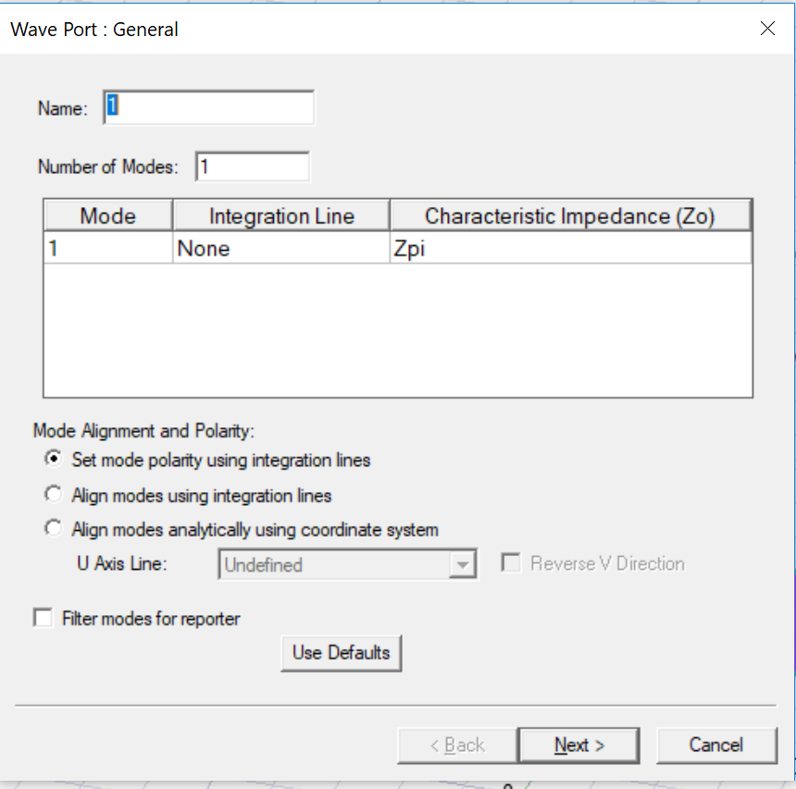
- (10 pts) There is no unique definition of impedance for a waveguide which does not support TEM mode. To figure out which impedance is used in HFSS simulation, first read the port 1 impedance at 8, 10 and 12 GHz and then identify the formula for the impedance calculations in HFSS.

Coaxial Line:

- (10 pts) What is the cutoff frequency of the first higher-order mode? Which mode is it?
- (10 pts) Plot the vector E and H field distribution of the TEM and the first higher order mode.

Circular Waveguide

- (10 pts) What is the cutoff frequency of the lowest and 1st higher-order modes? Which modes are they?
- (10 pts) Plot the vector E and H field distribution of the two modes.

